A. Exchange and transport in animals – Part 1
- Define ‘diffusion’
- State three places where diffusion occurs in the body.
- What is surface area to volume ratio?
- Which has the largest surface area to volume ratio, an elephant or a meerkat?
- State how the lungs are adapted for diffusion.
Biology
- What is a concentration gradient?
- What three factors affect the concentration gradient?
- Calculate the relative rate of diffusion and record in the table below.
What happens if the concentration difference is doubled?
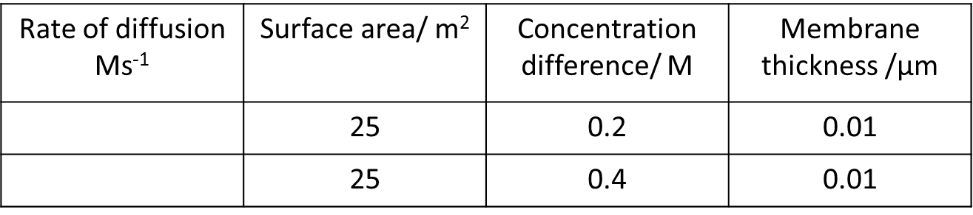
B. Exchange and transport in animals – Part 2
- Name parts A - H of the heart from the diagram below:
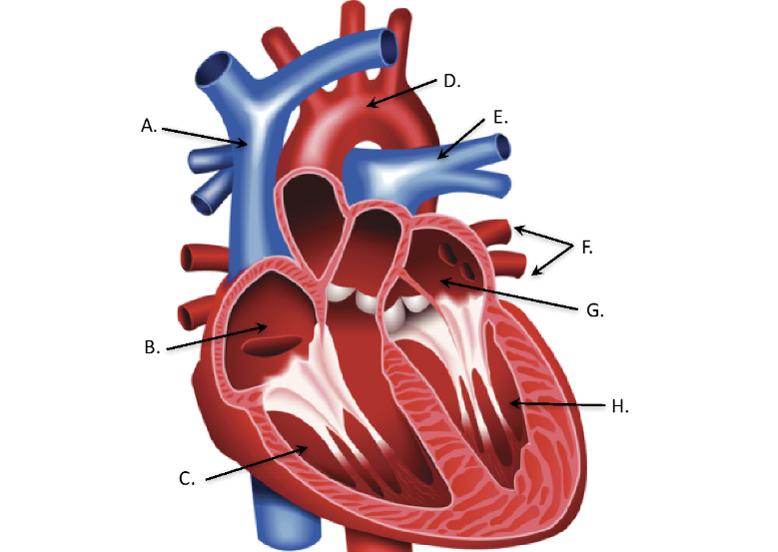

- What is a double circulatory system?
- What is a pacemaker?
- What is the role of the coronary arteries?
- Where does the left atrium pump blood to?
- Name the blood vessels that carry blood away from the heart.
- Which blood vessels are only one cell thick?
- Which blood vessels have thick muscular walls?
- Which blood vessels have valves?
- What is plasma?
- What is the role of a red blood cell?
- In what two ways can white blood cells fight infection?
- What is the role of platelets?
- What is the role of heart valves?
- What does stroke volume mean?
- What is the equation to find out the stroke volume?

C. Exchange and transport – Part 3
- When does respiration occur in cells?
- Copy and complete the table below:
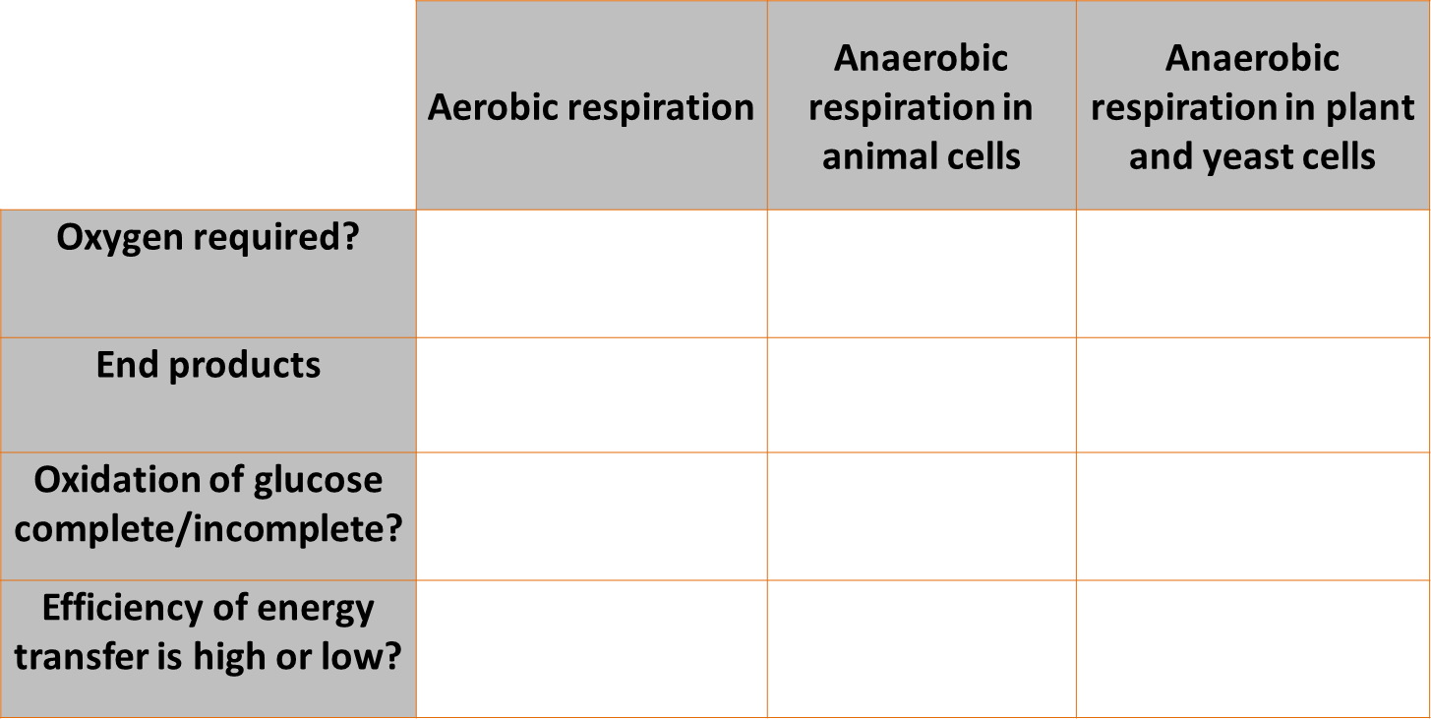

- Name three processes that organisms require energy for.
- What does the chemical formula C₆H₁₂O₆ represent?
- Write down the word equation for aerobic respiration in a plant cell.
- Describe three ways in which the body responds to vigorous exercise in order to ensure sufficient oxygen reaches the muscle cells.
- If exercise carries on for a long time, what happens to the muscles?
- Why is respiration described as an exothermic reaction?
- What is the definition of metabolism?
- Describe the process for removing lactic acid from the body.
- What is meant by the term ‘oxygen debt’?
- What is the soda lime used for in the core practical?

